PERSONAL INFORMATION

Name: IBRAHIM RANZU
Date of Birth: 20-03-1998
Address: Demra, Dhaka
Bangladesh
Mobile: +8801793336474
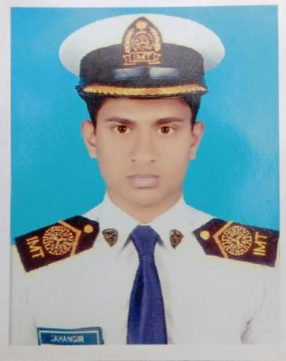Email: ronjusouth60@gmail.com

Career Objectives:

I am very much careful with my duties, I would like to upgrade myself on my relevant
Engineering side.
Career Summary:

I am an enterprising young professional intending to continue my development as a consultant. I think in terms of results and objectives, I am enthusiastic, and I work with decisiveness and conviction. I have a proactive attitude and find positive ways to stimulate and engage with people.
Computer skills:

1. Microsoft office 2003 ,2007,2010 ,2013
(Word, Excel, Access, Power Point, and Internet And windows XP, 7, 8,10)
2. Typing Efficiency is good Bangla & English.

Self Analysis:
1. Strong motivation and commitment for My Engineering work.
2. Endurance to work for long hours and under pressure.
3. Ability to work independently as well as a team member.
4. Commendable communication and presentation skills.
5. Exactitude and promptitude.
6. Eagerness to learn anything new and flair to travel in pursuit of knowledge.

Language Proficiency:

Language | Read | Write | Speak | Understand
Bangla | Excellent | Excellent | Excellent | Excellent
English | Good | Good | Good | Good
Hindi | - | - | Good | Good

Academic Qualification:

Exam Title | Concentration/Major | Institute | Result

DIPLOMA- INENGINEERING | Shipbuilding  TECHNOLOGY | Institute of Marine  Technology.(Munshigonj) | Continue(8th semester)

SSC(VOC) | Mechanical  TECHNOLOGY | BAWANY HIGH SCHOOL | GPA (05) Out of (05)

Training Summary:

Training Title | Topic | Institute | Country | Location
INDUSTRIAL TRAINING | Industrial  Mechanical | Latif Bawany Jute  Mills. | Bangladesh | Demra
Personal Details:

Name | : | IBRAHIM RONJU
Father’s Name | : | Aminul islam
Mother’s Name | : | Kona Begum
Permanent address | : | Demra Bazar, Dhaka-Bangladesh.
Contact address | : | IBRAHIM RONJU  Demra Bazar, Dhaka-Bangladesh.
Contact Telephone No | : | +8801793336474
Date of Birth | : | 20-03-1998
Marital status | : | Single
Nationality | : | Bangladeshi (By Birth).
Religion | : | Islam
Hobbies & Interests:

• Reading Books
• Traveling & Exploring New Places.

I hereby declare that the information given above is true to the best of my knowledge.

