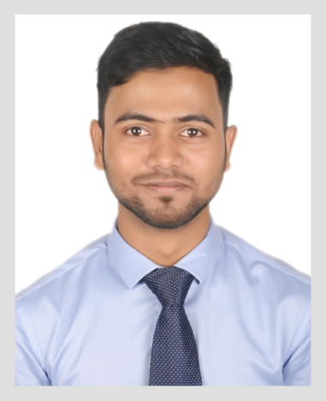
MD. SABBIR AHMED

Address: Hilalpur,Hetimgonj,Golapgonj, Sylhet

Cell: +8801710211772
E-MAIL: goodlucksabbir@gmail.com

Career Objectives:

To obtain an honorable position in educational sector that will provide present and future opportunities for growth, development and to use my educational knowledge & experience which help to increase social value of nation and to dedicate my whole effort to achieve institutional goal.

Educational Qualification

(B.sc Hon’s)
Institute Name : Metropolitan University, Sylhet.
Subject : CSE
Result : 3.34 (CGPA)
Year of Passing : 2018

Higher Secondary Certificate (H S C)
Institute Name : M.C Academy Model School & College, Sylhet
Education Board : Sylhet
Result : 4.40
Group : Science
Year of Passing : 2013

Secondary School Certificate (S S C)
Institute Name : Siraj Uddin Ahmed Accademy, Sreerampur, Sylhet
Education Board : Sylhet
Result : 4.81
Group : Science
Year of Passing : 2011

Job Experience

- Software Engineer at Top Soft from November 2018 to present
- Web Developer at Digita Interactive Limited from April 2018 to October 2018

Language Proficiency

- Bengali : Fluent in reading , writing & speaking.
- English : Fluent in reading , writing & speaking.
Professional Skills
- Operating System Platforms : Windows.
- Programming: C, C++, Java, Python, PHP, JavaScript.
- Mobile Application: Android, Mozilla Firefox.
- Web Development: HTML,CSS, PHP & MySQL, Ajax, JQuery.
- Research Toolkits & Others : MATLAB, SQL.
- Framework: Code Igniter, Bootstrap, Uikit
- Databases : MySQL
Extra curricular Activities

- Treasurer of Hilalpur Shapla Somaj Kollan Songho.

Self Assessment

- Willing to learn and build-up career by accepting responsibilities on all aspects.
- Energetic, Sincere, Hard working and Dutiful.
- Able to set prioritize and routine tasks.
- Able to work at any time any place.

Personal Information

Name : Md. Sabbir Ahmed
Fathers Name : Amirul Islam
Mothers Name : Sunara Begum
Date of Birth : 12 May, 1995
Marital Status : Single
Religion : Islam
Gender : Male
Nationality : Bangladeshi
Permanent Address : Vill: Hilalpur, P.O- Hetimgonj, P.S- Golapgonj,

Reference s

Sakhawat Hossain Saimon
Lecturer, Department of Computer Science and Engineering
Metropolitan University
Al Hamra, Sylhet-3100
Phone: +8801727412525
Email: sakhawat.saimon@metrouni.edu.bd

Md. Mahfujul Hasan
Assistant Professor
Department of Computer Science and
Engineering
Metropolitan University, Sylhet.
Email: mahfujul@metrouni.edu.bd
Contact: +88 01620431610

Declaration
I hereby declare myself that all the statement in this C.V is authentic complete and correct of the best of my knowledge and belief.

Signature
(Md. Sabbir Ahmed) Date: 14 February,2019

