Sabrina Yasmin
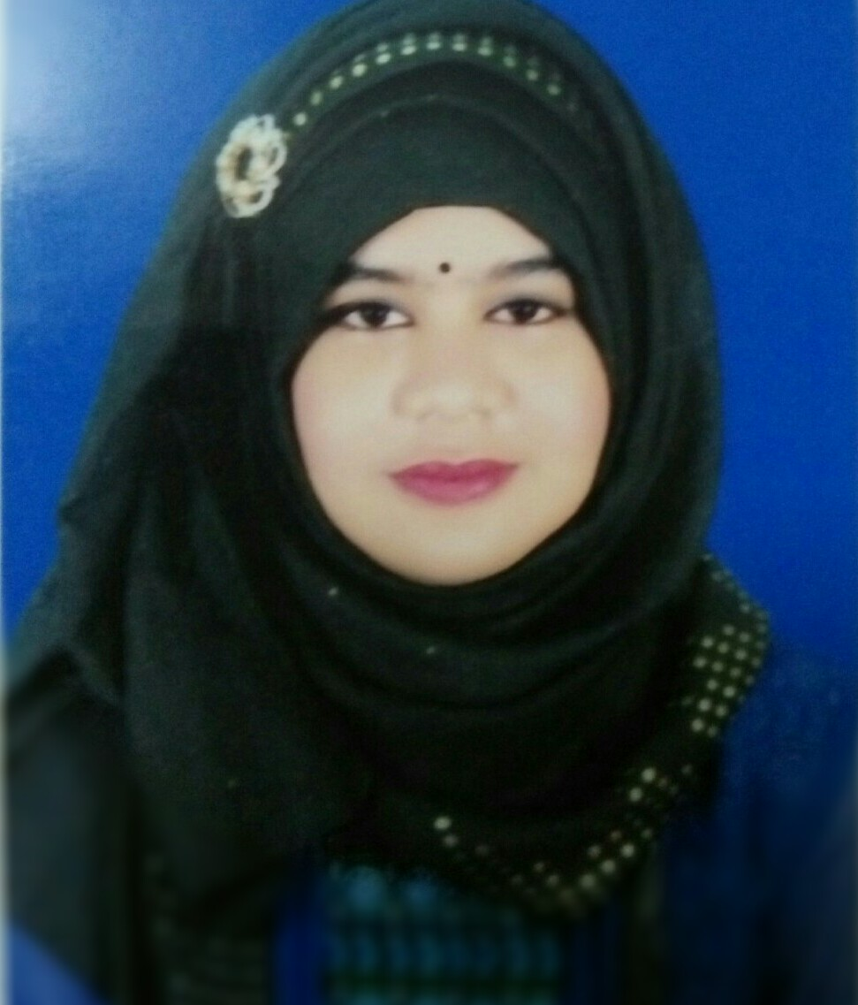
House no: 178, new road no: 02, old road no: 05,mirpur 12,DOHS,
Dhaka : 1216.
Email : s.lopa40@gmail.com
Phone no: 01786007417, 01959620605
Career Objectives

Self-motivated and hardworking fresher seeking for an opportunity to work in a challenging environment to prove my skills and utilize my knowledge & intelligence in the growth of organization.

Academic Details

Name of Examination | Name of the  Institution | University/  Board | Major/  Group | Year of  Passing | CGPA
M.S. | Jahangirnagar University | Jahangirnagar University | Physics | 2015 | 3.48 (Out of 4.00)
B.Sc. | Jahangirnagar University | Jahangirnagar University | Physics | 2014 | 3.30  (Out of 4.00)
Higher Secondary  Certificate  (H.S.C.) | Holy cross  College | Dhaka | Science | 2010 | 5.00  (Out of 5.00)
Secondary School  Certificate  (S.S.C.) | Sher-E-Bangla Nagar Govt.Girls’ High School | Dhaka | Science | 2008 | 5.00  (Out of 5.00)

Key Skills

- Have a good initiative taking personality and capable to handle multi-tasking assignments.
- A very flexible team player.
- Target oriented work culture, with ability to handle high stress levels with the virtue of patience.
- Good Leadership, Communication, Creative and Coordination skills.
- Ability to face and negotiate changes in professional life, and work positively.
- Posses the ability to effectively handle responsibilities at ease in high stress and fast –paced environment.

.

Academic Awards

- Board Scholarship from Education Board of Dhaka (for excellent results in SSC exam, ’06-‘07).
- Academic Scholarship from Jahangirnagar University in the academic years during the Undergraduate and Graduate study.

Computer Literacy

- Programming Languages : C & C++ (completed academic courses on them).
- Document Processing : MS office, MS excel , MS word
- Computational Analysis : Matlab.
- Others : Internet Browsing and E-mail Checking.

Extra-curricular Activities

- Publishing and presenting a project in msc which is fully based on optical transmission system tested at the opticwave software system.
- Being champion taking part in badminton Championship in annual sports 2009-10 organized by holy cross college.
- Taking part in organizing and participating actively in the cultural functions(dancing) at the respective organizations.
- Publishing and acting as an editor of a magazine named “Karjabilap” at the department of physics in Jahangirnagar University in 2011.
- Giving co-direction to a cultural program at the re-union of the department of physics in Jahangirnagar University in 2012.
- Being runner up taking part in women cricket championship in annual sport 2009-2010 organized by holy cross college.

Language Competency

- Bengali : Mother Tongue.
- English : Good in Reading & Writing, Listening & Speaking.

Personal Information

Father’s Name : MD. Rashidul hossain
Mother’s Name : Rashida khatun
Present Address : House no: 178, new road no: 02, old road no: 05,mirpur 12,DOHS,
Dhaka : 1216.
Permanent Address : Vill-north morail, P.O.-B.baria sadar, Thana-B.baria sadar, District-B.baria
Date of Birth : 10/11/93
Marital Status : Single

References

Dr. A. A. Mamun M Moshiur Rahman
Designation: Professor Designation:Associate Professor
Department of physics Department of physics
Jahangirnagar University Jahangirnagar University
Savar, Dhaka, Bangladesh Savar, Dhaka, Bangladesh
Email: mamun_phys@yahoo.co.uk Email: phy_mmr@juniv.edu
Phone:7791218(res),7791058(off) Phone: +8801552556254
Relation: Academic Relation: Academic

I hereby declare that the above mentioned details are true to the best of my knowledge.


Signature
(Sabrina yasmin)

