TASNIN CHOWDHURY SADIA | 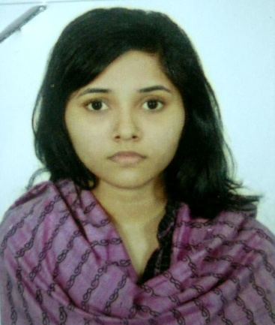
Address: House-8, Road-37, Block-C, Uposhohor, Sylhet, Bangladesh.
Mobile No : +8801681-207056
e-mail : sadiachowdhury9@gmail.com

Career Objective:
Investing the incorporated skills of exercising and executing view and decision making ability to expanding skills as a professional within a progressive organization, where expansion to new horizons the buzz word and which challenges it`s people.

Special Qualification:
Excellent with computer, precisely MS office, Internet browsing and email. Very efficient in English language.

Employment History:
1.Teacher ( February 2014 – December 2014)

Oxford International School.
Uposhohor, Sylhet.
Duties/Responsibilities:
English teacher.
2. |  | Coordinator ( October 1, 2016 - Continue)
3.Assistant |  | Edulink  Company Location: House-26, Road-14, Block-D, Shahjalal Upashahar, Sylhet.  Duties/Responsibilities:  Coordinator of GED  Teacher(August 26,2018-Continue)  Banyan British School  67 Kumarpara Road,block-c,sylhet  Duties/Responsibilities:  Science ,Social studies and religious studies teacher.

Academic Qualification:
Exam Title | Concentration/Major | Institute | Result | Pas.Year | Duration
A level | Chemistry, Physics | Khajanchibari International School and College. | Pass | 2013 | 2
O level | Math, Physics,  Chemistry, Biology, English. | Khajanchibari International School and College. | Pass | 2010 | 2

Training Summary:
Training Title | Institute | Country | Location | Year | Duration
Active Citizens Youth Leadership Training. | British council | Bangladesh. | Al Hamra | 2013 | 3 Days

Language Proficiency:
Language | Reading | Writing | Speaking
Bangla | High | High | High
English | High | High | High
Arabic | High | High | Medium

Personal Details :
Father's Name | : | Mudabbir Hossain Chowdhury
Mother's Name | : | Razia Chowdhury
Date of Birth | : | February 6,1995
Gender | : | Female
Marital Status | : | Unmarried
Nationality | : | Bangladeshi
Religion | : | Islam
Permanent Address | : | House-8, Road-37, Block-C, Uposhohor, Sylhet, Bangladesh.
Current Location | : | Sylhet.

Reference (s):
 |  | Reference: 01 | Reference: 02
Name | : | Mofakkir Hossain Chowdhury. | Rezaur Rahman
Organization | : | Exim Bank. | Edulink.
Designation | : | Senior Officer. | Test Administrator.
Mobile | : | 01715-294058 | 01722-783132
E-Mail | : | Mofakkir.hossain@gmail.com | Rajrahman99@gmail.com
Relation | : | Brother | Professional

