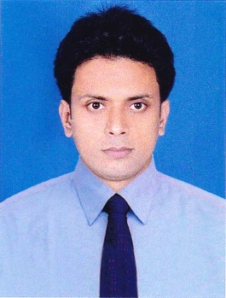
RESUME
OF
SAGAR KUMAR SAHA
KURIGRAM
Mobile: 01781335976
sahasagar1993@gmail.com

Career Objective:
Achieving a challenging job where I can use my technical and interpersonal skills, creativity and hard work in order to develop my career as well as to contribute in the rapid growth of company and the country.

Education Qualification:

B.Sc
Institute Name : Carmichael College, Rangpur.
Sub : Chemistry
Passing Year : 2018
Result : CGPA- 3.25
Name of University : National University

H.S.C
Institute Name : Rangpur Govt. College, Rangpur.
Group : Science
Passing Year : 2013
Result : G.P.A- 5.00
Board : Dinajpur

S.S.C
Institute Name : Ranigonj Bazar High School, Kurigram.
Group : Science
Passing Year : 2010
Result : G.P.A-5.00
Board : Dinajpur

Computer Skills:
Proficiency in word processing with Microsoft word, Data Processing with Microsoft Excel, Internet Browsing, Including working Knowledge in Microsoft access and Microsoft Power point.

Language Known:
Bengali is my native language, Good command over English in reading Writing Speaking and listening.

Interests and hobbies:
Travelling, Reading Book, Listening Songs etc.

Personal Details:
Name : Sagar Kumar Saha
Father’s Name : Ratan Kumar Saha
Mother’s Name : Mallika Rani Saha
Present Address : Vill: Ranigonj, Post: Ranigonj,
P.S: Chilmari, Dist: Kurigram.
Permanent Address : Vill: Ranigonj, Post: Ranigonj,
P.S: Chilmari, Dist: Kurigram.
Date of Birth : 15 Nov 1993
Home Dist. : Kurigram.
Marital Status : Unmarried
Blood Group : O+
Weight : 60kg
Height : 5 Feet 7 Inche
Nationla ID No : 824 248 6176

Reference:

1. 2. Uttam Kumar Saha  Vice Principal  Chatra Degree College  Pirgonj, Rangpur.  Mobile: +8801712-509081 | 2. Uday Kumar Saha  Lecture (Management)  Chatra Degree College  Pirgonj, Rangpur.  Mobile: +8801734-391957

I, the undersigned certify that, according to my knowledge and belief, this C.V correctly describes my qualification and myself.

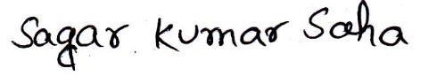

Date: Signature
(Sagar Kumar Saha)

