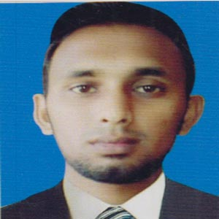
Curriculum Vitae
of
SHAHEL AHMED
Address
Vill :Syedpur, PO : Islampur,
Dist : Sylhet.
Mobile: +88 01737323795
E-mail: sahelahmed50@gmail.com

Career Objectives:-

To work for any respectful organization that motivates its employees to achieve excellence with personal effort ensuring the use of technology for the benefits of the organization itself and the society as well as for the country as a whole.
Educational Qualification:-

M.A(Sociology)
M.A ( Master’s) : National University
Institution : M.C College Sylhet.
Year : 2014.
Result : 3.05 (out of 4 ).

B.S.S(Sociology)
B.S.S (Honor’s): National University .
Institution : M.C College Sylhet.
Year : 2013.
Result : 2.80 (out of 4).
Higher Secondary Certificate (H.S.C)
Institution : Sylhet Govt. College.
Result : GPA 3.60 (out of 5).
Group : Humanities.
Passing Year : 2008.

Secondary School Certificate (S.S.C)
Institution : Hazrat Shahjalal High School.
Result : GPA 3.13(out of 5).
Group : Science .
Passing Year : 2006.
Board : Sylhet.

Work Experience:-

- I am worked as Assistant Manager from 11TH February 2014 to 30th July 2016 with SATATA M/P CO-OPERATIVE SOCIETY LIMITED . Atauer Complex (4th floor), Jollarpar Road, Sylhet-3100.

Computer Literacy Specification:-

- 03 Month Basic Computer Training from “Zamzam Training Institute”.
- Experienced in working with Windows 2000, XP, Vista, Windows 7, Windows 8, Windows 8.1.
- Other tools: Microsoft Office (Office 97-2010-2007) & Internet Browsing.
- Computer troubleshooting

Personal Information:-

- Father’s Name : Firuz Ahmed.
- Mother’s Name : Nurun Nahar Begum. Permanent Address : Village : Syedpur.
Post Office : Islampur.
Police Station : Shahparan.
District : Sylhet.
- Date of Birth : 17th January 1990.
- Birth Place : Sylhet.
- Gender : Male .
- Marital Status : Single.
- Nationality : Bangladeshi (By Birth).
- Religion : Islam .
- Height : 5 feet and 9 inches.

I hereby, am noticed that all information mentioned above is absolutely correct with the best of my knowledge.

Your Sincerely,

