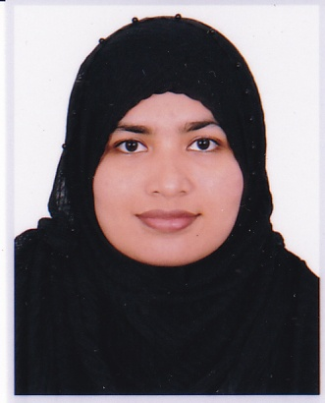
Resume
of
Samina Al Islam
Cell: 01718377614
Email: saminaislam2013@gmail.com
Address: S.R Chowdhury Cottage,Novag,Kamal Bazar Sylhet.

Carrier Objective:

To work in a healthy, innovative and challenging environment extracting the best out of me, which is conducive to learn and grow at professional as well as personal level thereby directing my future endeavors as an asset to the organization.

Scholastic Information:

Name of Degree | Institute/ University | Group/ Department | Board/ University | GPA/CGPA | Passing Year
B.Sc (Hons.)  in CSE | Metropolitan University ,Sylhet | Computer Science and Engineering | Metropolitan University | 3.02  (Out of 4.00) | 2017
HSC | Blue Bird School and College | Science | College | 3.60  (Out of 5.00) | 2012
SSC | Hazi Rashid Ali High School | Science | School | 4.75  (Out of 5.00) | 2010

Certificate Courses:

Course Name | Conducted By
Microsoft Office Management Course | Bhuiyan Computers (Pvt).Ltd
English Language Proficiency Course(Upper Intermediate Level) | Bhuiyan Computers (Pvt).Ltd

Computer skills:
 
- Standard MS office Software (Word,Power Point)
- Web Design and Web Development
- windows setup & other computer servicing

Communication Skills:

- Excellent interpersonal communication skills.
- Bangla: Native Language.
- English: Good Command over reading, writing & speaking.

Personal Profile:

Name : Samina Al Islam
Father’s Name : Md. Serazul Islam
Mother’s Name : Tahmina Khatun Chowdhury
Permanent Address : Vill- Sonupara, P.O- Kamal Bazar, P.S: Dakshin Surma, Dist: Sylhet.
Date of Birth : 30th December 1994
Nationality : Bangladeshi (By Birth)
Gender : Female
Marital Status : Unmarried
Blood Group : O(+)ve
Religion : Islam (Sunni)

About me/Interests/Achievement/Community relationship:

- Participated many debate competition (Both English and Bangla).
- I am consistent and flexible and cope up with any situation easily.
- Like to learn new things from the people around me. Also, I like to share my thoughts with them.
- Reading books,writing,internet .
- Interested to work in virtual world.

References:
Fuad Ahmed
Assistant professor
Department of CSE
Metropolitan University, Sylhet
Contact No: +8801611829316
Nazmin Akther
Senior lecturer
Department of CSE
Metropolitan University, Sylhet
Contact No: +8801727053435

Declaration:
I do hereby declare that all the above information are true & correct to the best of my knowledge and belief.


_______________________________________________
Signature

