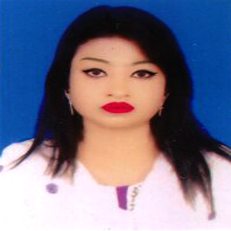
CURRICULUM VITAE

Sanjana Khan Urmi
House- 42, Road- 33, Block- E,
Section- 12, Pallabi, Mirpur, Dhaka-1216
E-mail: sanjanakhanurmi@gmail.com
Cell: 01945585896

CAREER OBJECT:

To acquire a position in an organization that is appealing a challenging and which offers an opportunity for professional career development where I would have scope to serve company in achieving the company's goals and objective.

Experience:
Name of Company : Uniqe Group
Designation : Assistant Executive (HR)
Duration : 2015 to 2017

EDUCATION QUALIFICATION:
Degree : B.A (Honours) (English)
Name of Institution : B.L College
University : National University
Result : 3rd Year (On Study)

Higher Secondary Certificate:
Name of Institution : Fultala Mahila College
Group : Commerce
Passing year : 2012
Result : G.P.A- 3.70 (out of 5)
Board : Jessore

Secondary School Certificate:
Name of Institution : Mohadebpur R.B.S Secondary School
Group : Science
Passing year : 2010
Result : G.P.A- 3.38 (out of 5)
Board : Jessore

PERSONAL INFORMATION:

Name : Sanjana Khan Urmi
Father’s Name : Nuruzzaman Khan
Mother’s Name : Arzina Begum
Date of Birth : 12 February 1994
Permanent Address : 467, Khan Bhai - Lodge
Jessore Road, Daulatpur, Khulna
Home District : Khulna
Marital Status : Single
Religion : Islam
Nationality : Bangladeshi (By Birth)

LANGUAGE PROFICIENCY OF OTHER’S SKILLS:
Fluent in Bengali & English

COMPUTER LITERACY:
Operating Software: Windows Office including MS. Word, MS. Excel, MS. PowerPoint.

REFERENCE:
Md. Ahsan Habib Ratan
Director (Land Depertment)
Uniqe Group
Cell: 01769501564

Signature

(SANJANA KHAN URMI)

