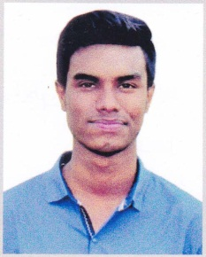

SARWAR HOSSAIN
+8801954811059

mdsarwarh107@gmail.com


30, East Razabazar, Dhaka-1215









Bangladeshi 18 years Single O+ 5’5” Available

Career Objectives: A challenging career in a dynamic organization that promises opportunity and excellent job environment for career growth, Utilize the knowledge, skills and efforts to work effectively in an organization. Be a responsible team player, making significant contributions to the success of the organization.
  EDUCATION/CERTIFICATION  Name of Degree: Diploma in Mechanical Engineering  Institution : National Institute of Engineering and  Technology (NIET)  Group : Mechanical  Board : BTEB  Status : Running  Name of Degree : Secondary School Certificate  Institution : Nabinagar Pilot High School,  Group : Mechanics (Vocational)  Board : BTEB  Result : 4.29 In 5.00  Year of Passing : 2017    PERSONAL APPRAISAL  - Comprehensive problem solving abilities,  - Good verbal and written communication skills  - Ability to work individually & group wise  - Ability to deal with people  - Willingness to learn  CORE SKILLS  Responsible Honest Punctual Hard Worker    100% 100% 100% 100% |  |  | TECHNOLOGICAL SKILLS  - MS Word  - Internet Browsing  - Power point  - Data Entry  - PC Basic and Software Problem Solving  - PC Installation and Hardware Basic    LANGUAGE SKILLS  - English : (Medium) skill on reading, writing, listening & speaking  - Bengali : Excellent in all form  INTEREST AND HOBBIES          PERSONAL INFORMATION:  Father's Name : Farid Uddin Kalon  Mother's Name : Sabin Begum  Death of Birth : 12/02/2000  Nationality : Bangladeshi  Religion : Islam  Marital Status : Single  Permanent Address : Gopinathpur,Word # 3, Nabinagar, Brahmanbaria.

