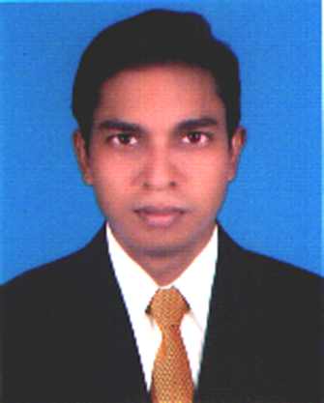
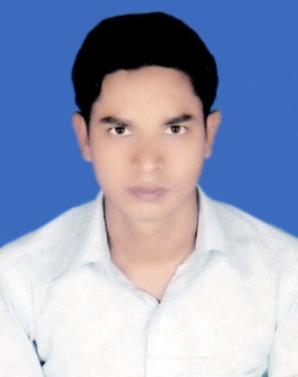
RESUME
OF
MD. SHAHIN UDDIN
Contact No.-+088-01764865208
Objective
To work as a dedicated employee in an organization where I can use my efficiencies and enthusiasm and help myself to grow as a competent professional. I look forward to work in a challenging, dynamic and disciplined job environment to enrich my professional skills, competency. Very much eager and sincere to work and have the capability to learn and introduce with the new environment with a short period of time than others.

Working Experience

I have been working experience at "Agrogoti Social unnoan Sangastha" with 3 Years which provide field worker as Micro-credit programmer. Where I have to work hard with sincerely.

Educational Qualification

Masters of Business Studies(MBS):
Name of Institute : Kushtia Govt. College, Kushtia.
Department : Accounting
Duration of Study : 1 Year
Examination : 2011 (Held in 2014)
Result : 2nd Class.

Bachelor of Business Studies(BBS):
Name of Institute : Kushtia Govt. College, Kushtia.
Department : Accounting
Duration of Study : 4 Years
Examination : 2010 (Held in 2012)
Result : 2nd Class

Higher Secondary Certificate (H.S.C):
Name of Institute : Police lines School & College, Kushtia.
Group : Business Studies
Board : Jessore
Examination : 2006
Result : GPA- 4.00 (out of 5.00)

Secondary School Certificate (S.S.C):
Name of Institute : K.H.N Secondary High School
Group : Science
Board : Jessore
Examination : 2004
Result : GPA- 3.06 (out of 5.00)

Personal Information
Name : Md. Shahin Uddin
Father’s name : Oazed Ali
Mother’s name : Mrs.Monjera Khatun
Permanent Address : Vill.- Katdahchar.P.O.- Halsa, P.S.- Mirpur, Dist.-Kushtia.
Present Address : Vill.- Katdahchar.P.O.- Halsa, P.S.- Mirpur, Dist.-Kushtia.
Date of birth : 09th November, 1988
Marital status : Married
Religion : Muslim (Sunni)
Nationality : Bangladeshi
Sex : Male
National I.D. No : 5019458401747

Computer Skill
I can operate: MS-Word, MS-Excel, MS-Access, MS-Power point, Adobe Photoshop. I can correspond with the foreigners by internet browsing, e-mail, fax and others.

Language Competence
Excellent knowledge of understanding, reading and writing English and Bengali language. Excellent fluency in spoken English and Bengali.

References
1. Md.Jahidul Islam(Biplob)
Managing Director
M/s Three Star Agro Industries
Cell Phone 01711-330690
Email. Threestaragro.info@yahoo.com
2. MD. Kawser Ahmed
Social Islami Bank Bangladesh Ltd.
90/01, 29 Flour, Head Office,
Motijil Dhaka- 1000.
Cell: 01711-219750

(Md. Shahin Uddin)
Signature of Applicant

