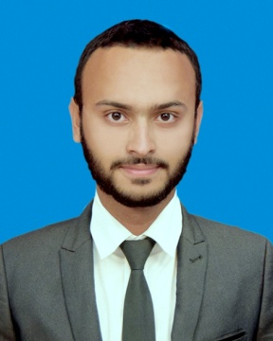
Robin Bhattacharjee

Bahubal R/A,Road No-1, Shahporan,Khadim Nagar, Sylhet 3103
 01633-736348
robinsd1694@gmail.com

CAREER OBJECTIVE

To serve an organization by utilizing the technical, analytical and team building skills in optimum way with sheer determination and commitment for the betterment of the organization.
EDUCATIONAL QUALIFICATION

Passing  Year | Degree | Concentration | Institution | Result
2017 | Bachelor of Business Administration(BBA) | Marketing | Sylhet International University | CGPA 2.92  (Out of 4)
2012 | Higher Secondary Certificate (HSC) | Business Studies | Sylhet Government College, Sylhet | GPA 4.20
2010 | Secondary School Certificate(SSC) | Business Studies | Hazrat Shahparan High School, Sylhet | GPA 4.19

EXPERIENCES
Internship at Mutual Trust Bank Ltd, Sylhet Branch
Department: Liability Operations
Time Period: April 02, 2017 to July 02, 2017
Working experience to know all type of account with good understanding of documentation as per Bangladesh Bank guideline, internal and external process, circular and PPG (Product Program Guide).
Responsibility:
- Account opening from (ADF) receiving from all acquisition channel accordingly
- Record keeping
- Prepared daily, weekly and monthly MIS

EXTRA CURRICULAR ACTIVITIES

- Chief sgt at arms at “Rotaract club of sylhet International University”
- Founder Member at “ASTHA” (Social and Voluntary Organization).

SKILLS & COMPETENCIES

[Computer Literacy:
- Good command of Microsoft Office tools (Word, PowerPoint, Excel, Access)
Communication:
- Good command in any form of communication with corporate officials (as several companies were visited to prepare reports of several courses), faculty members, staffs & students.
- Contacted with company’s heads of department or executives for the necessity of the club activities at University.
Language:
- Proficient in spoken & written communication of both in Bengali & English.

PERSONAL DETAILS

Name : Robin Bhattacharjee
Father’s Name : Rosomoy Bhattacharjee
Mother’s Name : Dipshikha Bhattacharjee
Date of Birth : June 16,1994
Sex : Male
Nationality : Bangladeshi
Religion : Hinduism
Permanent Address : Bahubol R/A,Shahporan, Khadim Nagor Sylhet-3103

REFERENCES

Birendra Chandra Das  Deputy Director  Bangladesh Bank,Head office,Dhaka  Email: birendra.chandra@bb.org.bd  Cell: 01717-021713 | Samir Kumar Biswas  Assistant General Manager  Sonali Bank ltd,Principal office,Brahman Baria  Cell: 01712-210698

Robin Bhattacharjee

