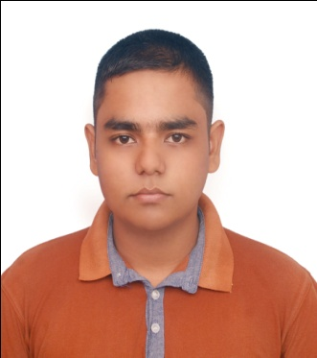
CURRICULUM VITAE
Of
Shoshi Shakar Ghosh
Borgul,Noya Bazar,Akhalia,Sylhet.
Mobile: +88 01792559439
E-mail: surjoghosh176@gmail.com

OBJECTIVE

To upgrade myself as an efficient, honest & diligent person in a wonderful environment from where I will get guideline to build a challenging career. My promise, drive & attitude deserve sophisticated job in an organization, which can guide me face challenges of the new millennium.

EDUCATION QUALIFICATION

Name of Exam :Bachelors of Business Administration (BBA)
Department of Management
On Going 4th year
Name of Exam : Higher Secondary Certificate (HSC)

Institute :Sylhet Commerce College, Sylhet.
Result : GPA - 4.92
Group : Business Studies
Board : Sylhet
Year of Passing : 2015

Name of Exam : Secondary School Certificate (SSC)
Institute :Border Guard Public School And College , Sylhet
Result : GPA - 4.19
Group : Business Studies
Board : Sylhet
Year of Passing : 2013

SPECIALITY

- Punctual and committed to work.
- Responsible and disciplined.
- Feel comfort to work with group.

SELF ASSESSMENT

- Willing to learn and build-up career by accepting responsibilities on all aspects.
- Energetic, Sincere, Hard Working and Dutiful.
- Able to set prioritize and routine tasks.
- Able to work at any time any place.

EXPERIENCE:
- Company : Force n Focus Ltd.
Position : Field Controller, Sylhet Division.
Experience Year : 4 Years.
- Company : MRCB Ltd.
Position : Field Interviewer, Sylhet Division.
Experience Year : 1 Years.
- Company : Abul Khayer Group & Company Ltd.
Position : Brand Promoter, Sylhet Division.
Experience year : 2 Years.
Project name : Marks All-rounder Event, School Activation,
Marketing Promotion.
- Company : Priti Research And Consultancy Services.
Position : Field Supervisor, Sylhet Division.
Experience Year : 1 year.
- Company : QUERY Bangladesh.
Position : Field Controller, Sylhet Division.
Experience Year : 3 year.

COMPUTER PROFICIENCY

Office Program : MS Word, MS Excel, MS Powerpoint & Internet Browsing.

LANGUAGE PROFICIENCY

Bangla :Good in speaking, writing, reading and listening.

English :Good in speaking, writing, reading and listening.

PERSONAL PROFILE

Name : Shoshi Shakar Ghosh
Father’s Name : Shuvrangshu Kumar Ghosh
Mother’s Name : Gita Rani Ghosh
Permanent Address : Borgul,Noya Bazar,Akhalia,Sylhet
Date of Birth : 19th September, 1997
Religion : Hindu
Marital Status : Unmarried
Gender : Male
Nationality : Bangladeshi
Blood Group : B+

I hereby declare myself that all the statement in this C.V. is authentic complete and correct of the best of my knowledge and belief.

shoshi
Signature & Date

