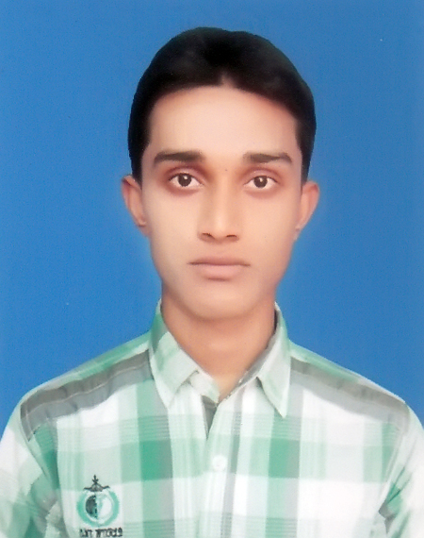
CURRICULUM VITAE
Md.Amanullah Kabir
Vill:Biraldha Mazar,P.O:Shibpur Hat,
P.S:Puthia,Dis: Rajshahi.
Mobile:01717-901660
E-mail:161shuvo@gmail.com
Career Objective:
Building up a rewarding career in an organization that provides structured career advancement within the extent of competitive and dynamic profession with sincerity, punctuality, commitment, self-competency and hard work.
Educational Qualification:

Bachelor of Social Science (BSS):
Department  Name of Institution  Session  Board | : Social Work  : Rajshahi College  : 2014-15  : National University

Higher Secondary Certificate (HSC)
Name of Institution  Group  Year of Completion  Board  GPA | : Biraldha College  : Humanities  : 2014  : Rajshahi  : 4.80 out of 5.00
School Secondary Certificate
Name of Institution  Group  Year of Completion  Board  GPA | : Biraldaha S.K.A.S High School  : Humanities  : 2012  :Rajshahi  : 4.81 out of 5.00

Language Proficiency

- Bengali: Mother tongue. Excellent in speaking, reading and writing
- English: Proficient in reading, writing and Fluent in Speaking

Computer Proficiency

- Working Knowledge in MS office (MS Word, MS Power Point, MS Excel)
- Can work with both Office 2007 and Office XP.
- Knowledge about Internet exploring.
Area of Interest:
- Public Relations
- Listening to music
- Reading
- Traveling;

Personal Competency

- Highly self- motivated
- Self-competency and hard work
- Challenging with others
- Punctuality and commitment

Personal Details
Name  Father’s name  Mother’s Name  Present Address  Permanent Address  Date of Birth  Nationality  Religion  Sex  Marital Status | : Md. Aman Ullah Kabir  : Md. Alomgir Kabir  : Most. Shahanaz Kabir  : Village –Biraldah; P.O. Shibpur Hat; P.S. Puthia; District- Rajshahi.  : Village –Biraldah; P.O. Shibpur Hat; P.S. Puthia; District- Rajshahi.  : December 28, 1996  : Bangladeshi  : Islam  : Male  : Unmarried

Reference
Md. Shalauddin
Medical Service Officer
Eskayef Bangladesh Ltd. (SK+F)
Mobile: +88-01710140310

I hereby disclose that the above information is true and complete to the best of my knowledge and beliefs.

Sincerely Yours

Md. Amanullah Kabir

