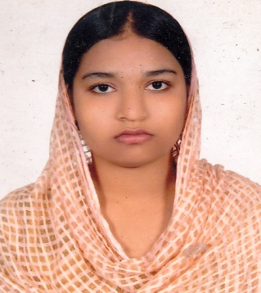
RESUME

OF
SONIA AKTER

MAILING ADDRESS:

957, Lane-12, East Badda, Post

Office Road, Badda, Dhaka-1212

Cell: 01307536826, 01533693711, E-Mail: ardisadia@gmail.com
E

CARRER OBJECTIVE:

Looking for an opportunity to utilize my strengths to build my career that would intrinsically help me in achieving greater practical excellence in technical domain, exceptional hardworking nature along with good communication skills to explore the requirements and come up with innovative solutions.

EXPERIENCE:

June 2018-December 2018
Executive (Admin), Trade Vally
Company Address: 72/1, Property Rise, D.I.T Road, Malibag, Dhaka-1217.

COURSES:

- Professional Back office Services (PBS) from 19 March to 17 June-2019
Name of Institution : Bangladesh Association of Call Center & Outsourcing
Passing Year : 2019

- Advance Computer Application Course (Four month)
Name of Institution : National Youth & Technical Training Center
Passing Year : 2018
Result : A+

EDUCATION QUALIFICATION:

- Masters of Social Science (M.S.S)
Name of Institution : Govt. Titumir College
Department : Economics
Passing Year : 2014
Result : 2.97 (Out of 4.00)
Name of University : University of Dhaka

- Bachelor of Social Science (B.S.S)
Name of Institution : Govt. Titumir College
Department : Economics
Result : 2.87 (Out of 4.00)
Passing Year : 2013
Name of University : National University

- Higher Secondary Certificate (H.S.C)
Name of Institution : National College Dhaka
Group : Humanities
Passing Year : 2009
Board : Dhaka
Result : GPA- 4.30 (Out of 5.00)

- Secondary School Certificate (S.S.C)
Name of Institution : Uttar Bhitabaria Azharia Islamia Dakhil Madrashah
Group : Science
Passing Year : 2007
Board : Madrashah Board
Result : GPA-4.00 (Out of 5.00)

COMPUTER KNOWLEDGE:

Ability to work with Windows XP, Microsoft word, MS Access, MS Excel, Power Point, E-mail and Internet browsing.

PERSONAL INFORMATION’S:
Name : Sonia Akter
Father’s Name : Md. Sakil Ahmed
Mother’s Name : Taslima Begum
Permanent Address : Vill: Bhitabaria, P.O: Bhita Baria
P.S: Bhandaria, Dist: Pirojpur
Date of Birth : 15th June 1992
Sex : Female
Height : 5 feet 3 inch
Religion : Islam
Nationality : Bangladeshi (by birth)

PERSONAL COMMENTS:
I am energetic, self-motivated, ambitious, hardworking & sincere & result oriented person. I am sensitive but always willing to learn and love to do anything that allows me to be creative.

LANGUAGE PROFICIENCY:

Strong & good communication in Bangla (Mother tongue) &
English (Foreign Language)

DECLARATION:
I declare that all information presented here are true to my knowledge .if required and where applicable, this document can be supported by appropriate & authentic corticated/Papers.

Sonia Akter
Date: .......................

