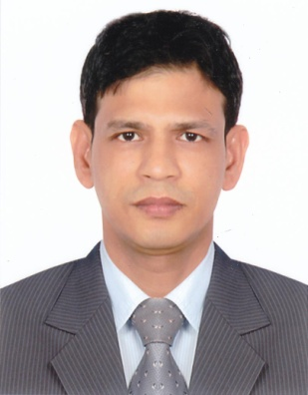
CURRICULAM VITAE
Mohammed Sopon
Dhaka, Bangladesh
Mobile : +8801534589704
E-mail : mohammedsopon73@gmail.com

Career Objective
To work in dynamic organization that offers significant exposure, challenging work
environment and growth opportunities to utilize my skills to an optimum thereby
embarking upon a career that is intellectually stimulating and professionally
rewarding.
Skills:
Pastry & Bakery Chef (Commis 1) and also know some Indian & Arabic sweet items.

Work Experiences
1) 5 years of work experiences as commis 1 in the pasty & bakery at Al Diar Siji hotel
& hotel apartments, Fujairah, 5 Star luxury hotel (November 5, 2009 to March 15,
2015).
2) 3 years of work experiences as a head bakery man at ADNH COMPASS in
Fujairah, UAE (a branch of Abu Dhabi National hotels) from (March 19, 2015 to
March 20, 2018).
About the Role:
Report to Pastry Chef.
Organize together with the pastry shifting in the section with regards to mise-en-place
production and its service. Take orders from the Pastry Chef and carry them out in the
correct manner. Take responsibilities to complete the daily check list regarding
mise-en-place and food storage. Work to the specifications received by the Pastry
Chef regarding portion size, quantity and quality as laid down in the recipe index.
Check the main information board regarding changes in any banquets or other
information regarding the organization. Report any problems regarding failure of
machinery and small equipment to the Pastry Chef and to follow up and ensure
necessary work has been carried out. Pass all information to the next shift about

functions. Responsible for buffet desserts at the restaurants and banquet functions.
Supporting to Pastry Chef in order to making menus for special events & Ala Carte
desserts. Making daily requisitions. Following HACCP files and training. Assisting
with the orientation of new team members. Conducting appraisals and feedback
sessions. Making Ala Carte production for three outlets. Supporting to banquet
functions. Ensuring guests live the “Ultimate Experience”. Ensuring restaurant, bar as
well as pool and lounge set up is according to set standard. Ensuring that food is
prepared to agreed recipes and standards.

Awards
1) Got the employee of the month in April 2011.
2) Got the 2 years of continuous service in Al Diar Siji hotel.
3) Got the 5 years of continuous service in Al Diar Siji hotel.
Educational Qualification: SSC passed.
Educational Attainment:
Telephone Manners Certificate (December 15, 2009).
Introduction Performance Management Certificate (May 14, 2010).
HACCP Awareness (February 25, 2016) & (July 14, 2016).
Personal Details:
Nationality : Bangladeshi
Date of Birth : 01-01-1985
Marital Status : Married
Gender : Male
Religion : Muslim
Languages : Bangla, Hindi (Fluent) & English (Poor)
Computer Skills: Internet Searching, E-mailing, Web browsing.
Strengths:
Positive Attitude & Energetic
Confident & takes initiative
Smart Worker
Ability to accept challenges quick learner
Declaration:
I hereby declare that the information’s furnished above are correct up to the best of
my knowledge and bear the responsibility for the correctness of the same.

