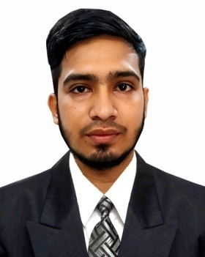
CURRICILUM VITAE
Of
RADUAN ALI

CONTACT INFORMATION
- Address : Shibgong,Sobujbaag, Sylhet.
- Phone : 01731980104
- G-mail : raduanali30@gmail.com
PERSONAL DETAILS .

- Name : Raduan Ali
- Father’s Name :Koramoth Ali.
- Mother’s Name :Forida yasmin
- Date of Birth : 12/10/1996
- Nationality : Bangladeshi (By birth)
- Gender : Male
- Blood group : Ab+ (Ab. Positive)
- Marital status : Unmarried.
- Religion : Islam.
- Present Address : Shibgong,Sobujbaag,Road -01,House-02.,Upazilla - Sylhet Sadar, Dist.-Sylhet.
- Permanent Address : Barlekha,Moulivibazar .

- CAREER OBJECTIVE.

Aim to work creatively in a competitive and challenging working environment with strong responsibility and commitment where job satisfaction and career development will be provided.

- EDUCATIONAL QUALIFICATION .
B.A.(Bachelor of Arts in English).
University : Leading University, Sylhet.
- Subject : English.
- Program :English
- Year of passing : 2019.
- Result : CGPA 2.92 (out of 4.00).

H H.S.C. (Higher secondary certificate)
- Board : Sylhet.
- Institute : Barlekha Degree college.
- Group : Humanities
- Year of passing : 2015.
- Result : 3.33 (GPA).
S.S.C. (Secondary School certificate)
- Board : Sylhet.
- Institute : Poylowan Bari High School.
- Group :Humanites.
- Year of passing : 2013.
- Result : 3.81 (GPA).
- COMPUTER COURSE.
Basic Computer Course.
- Institute :The It AD, Sylhet.
- Duration : Three month.

- COMPUTERSKILLS .

- Have good knowledge in Microsoft word, Excel, Power point, Access, Windows.
- Have good knowledge of using Internet & E-mail.
- LANGUAGE SKILLS.

- English (Conversional & fluent reading/writing), Bengali (Fluent reading/writing).
EXPERIENCES.
- Have a teaching experience as a privet tutor
- Products selling job in online
- Online business in medidel company.(Medicine)
REFERENCE
Md. Rezaul Karim
Head
Department of English
Leading University, Sylhet
Mobile: 01711467396

I, hereby declare that the above mentioned information is correct to the best of my knowledge.
( Raduan Ali )

