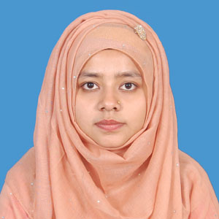
CURRICULUM VITAE
OF
Mst. Sultana Begum
Contact: 01728287456
E-Mail:sultana87013@gmail.com

CAREER OBJECTIVE:

To work for a renowned and suitable organization where I can use my dynamic skills and acquired knowledge and which can help me to learn, grow and eventually take greater responsibilities.

ACADEMIC PROFILE:

Degree title | Bachelor of Science (BSC)
Department | Computer Science & Engineering
Institution | Sylhet International University.
Passing Year | 2016
Result | CGPA 3.32(out of 4.00)

Degree title | Higher Secondary Certificate (HSC)
Department | Science
Institution | Noorjahan Memorial Women’s Degree College, South Surma.
Passing Year | 2011
Result | GPA 3.60(out of 5.00).
Board | Sylhet

Degree title | Secondary School Certificate (SSC)
Department | Science
Institution | Eklimiah Dipakkhik High School, Ram pasha.
Passing Year | 2008
Result | GPA 4.06(out of 5.00).
Board | Sylhet

COMPUTER LITERACY:

- MS office. Ms Excel. Ms PowerPoint. Applications.
- Good Typing skill.
- C programming. Java. HTML. PHP language etc.
- Internet Browsing and E-mail.
LANGUAGE PROFICIENCY:

Language Name | Speaking | Reading | Listening | Writing
Bangla | Good | Good | Good | Good
English | Good | Good | Good | Good

WORKING EXPERIENCE:

- Working as a teacher in “Classic International School & College” from January 1 2017. Responsibility performed:
- Teaching ICT, Higher Math, Physics.
- Supervising students in hostel.

PERSONAL STRENGTH:

- Self-Motivated
- Energetic
- Punctual
- Leadership Quality
- Team working

PERSONAL INFORMATION:

Name : Mst. Sultana Begum
Father’s Name : Mohd. Saleh Ahmed
Mother’s Name : Sajeda Begum
Date of Birth : 10Th November 1991
Blood Group : O+
Nationality : Bangladeshi
Religion : Islam
Marital Status : Single

CONTACT ADDRESS:

Mailing Address: Permanent Address:
Village. Rampasha Village. Rampasha
P.s . Bishwanth P.s . Bishwanth
Post office. Rampasha Post office. Rampasha
Post code. 3100 Post code. 3100
District. Sylhet District. Sylhet
REFERENCE:

Professor Md. Ruhul Amin  Dean, School of Business  Sylhet International University  &  Assistant Professor International Relations  Dhaka University  Cell Phone : 01711641679 | Professor Rishi Kesh Ghose  Dean, School of Science & Engineering  Sylhet International University  Cell Phone : 01715357237

Signature.

-------------------------
(Mst. Sultana Begum)

