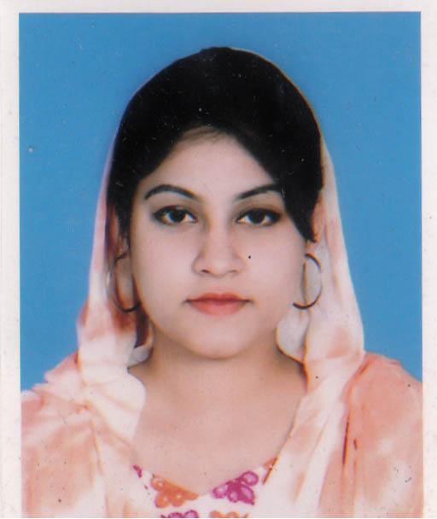
Curriculum Vitae Of
Ifrat Jahan Sunmoon
Present Address:  Waves-B-116,East Dorgah Gate, Sylhet City Corporation,  Sylhet-3100. | Contact Address:  Email: ifratjahansunmoon94@gamil.com  CellPhone: +8801623191150/01731022966

Objective
Objective

To obtain a responsible position through which I can utilize my knowledge, enhance my skills as well as can acquire the ability to face a high level of challenges, and get myself provided with varied experience and at the same time I would like contribute my best to the organization.

Educational Qualifications:

Level | Name of Examination | Group/Subject | Grade | Grade |  | Board  /University | Year of passing
 |  |  |  | GPA  /CGPA | Out of | Board  /University | Year of passing
Post Graduation | MBA | Accounting | Grade | 3.13 | 4.00 | Leading University,  Sylhet | 2017
Graduation | BBA | Accounting | Grade | 2.79 | 4.00 | Leading University,  Sylhet | 2016
HSC/Equivalent | HSC | Business Studies | Grade | 5.00 | 5.00 | Sylhet | 2012
SSC/Equivalent | SSC | Humanities | Grade | 3.94 | 5.00 | Sylhet | 2010

Computer Knowledge

- I have completed 3 month computer courses from NYDTC in Sylhet.
- Able to prepare any type of documents with MS word.
- Able to produce any type of data based calculation sheet with Ms Excel.
- Having knowledge on Internet browsing and e-mail.
Language Proficiency

Language name | Speaking | Reading | Listening | Writing
Bangla | High | High | High | High
English | Medium | Medium | High | Medium

Interest :

- Participating creative and smart work.
- Traveling, listening music,and reading books.
- Watching English movie specially action.
Self-Assessment and extra curriculum:

- Strong desires for leading an honest life with dignity.
- Energetic, Sincere, Hard working, honest and Dutiful.
- Able to work at any time at any place.
- Ability to work with a team.
Personal Profile:

Name : Ifrat Jahan Sunmoon
Father’s Name : Md. Ismat Ali
Mother’s Name. : ShahidaAkther Chowdhury
Present Address :Waves-B-116, East Dorgah Gate, Sylhet City Corporation, Sylhet-3100
Permanent Address : -Do-
Date of Birth. : 14 April 1994
Gender : Female
Nationality : Bangladeshi
Religion : Islam
Marital Status. : Unmarried
Cell Phone : +8801623191150

References:

SHAH MD.ENAMUL HAQUE MD.KUTUB UDDIN
Income Tax & company Lawyer Director,Family planning
Waves-B-116,East Dorgah Gate, Sylhet. Division of Sylhet, Sylhet.
Cell : 01712708235. Cell :01711332064
Declaration:

I would be appreciated if you give me an opportunity to work with you and to execute myself with your support. All of my information provided here are correct and complete.

Yours Sincerely

……………………..
(IfratJahan Sunmoon)
Date:

