Resume of Tamim Ahmed Sobuj

“Hatimbag, Road no. 2 ,House No. 3,Shibgonj, Sylhet
Mobile No: +8801752048665
E-mail: tamimahmedsobuj1995@gmail.com ”

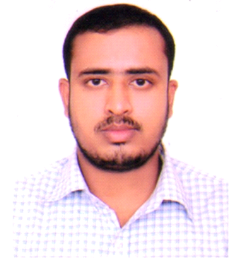

Career Objective:
To work in a challenging and competitive environment where strong sense of responsibility and commitment requires, where dignity of work provides job satisfaction and the place of work provides potential avenues for learning and growing and to achieve top-level in the hierarchy of the organization.

Academic Qualification:

M.S.S(Masters of Social Sciences)
Name of the Institute: Shahjalal University of Science and Technology, Sylhet.
Session: 2016-17
Subject: Anthropology
Result: CGPA-3.19(Out of 4.00)2017

B.S.S(Bachelor of Social Science)
Name of the Institute: Shahjalal University of Science and technology, Sylhet.
Session: 2012-2013.
Subject: Anthropology
Result: CGPA-3.07 (Out of 4.00)2016

H.S.C (Higher Secondary Certificate)
Name of the Institute: Shahjalal City College, Sylhet
Board: Sylhet.
Group:General.
Result: GPA-4.40 (Out of 5.00) 2012.

S.S.C (School Secondary Certificate)
Name of the Institute: KamrakhaiJoynogorDakhil Madrasah.
Board: Madrasah
Group: General.
Result: GPA-4.69 (Out of 5.00)2010.

Trainings & Workshops:
Four days long Active Citizens Youth Leadership Training, Jointly organized by: The Hunger Project, Bangladesh & British Council.

Two days long National Go Green Summit, Organized by Dept. of Geography & Environment of SUST.

Voluntary Works:
Name of Organization | Position
TIB | Yes Friends
Sonchalon | General Member
NirbanSylhet | General member
The Hunger Project | Volunteer
Communication Skill:
Excellent in Speaking and Writing Bangla (Mother Language).
Very good in Speaking English and Excellent in writing English.

Computer Skills:
Completed courses in Elementary Computer (Introduction to Computer, Database
Management) from Department of Computer Science and Engineering, Shahjalal
University of Science and Technology, Sylhet.

Have a Good command over Statistical Package for the Social Sciences (SPSS)

Microsoft Office Package: MS Word, MS Excel, MS PowerPoint.
Others: Advanced Internet Operations etc.
Experience:
A research Monograph on “The impact of folk and modern medical services in the life of the people ofalumpur village”

Field work research on“Lifestyles: an observation on khasi community at Meghalaya, India”

Personal Information:
Name: Tamim Ahmed Sobuj
Name(Bangla): তামিমআহমেদসবুজ
Father’s Name: Md.SurukMiah
Mother’s Name: Shefa Begum
Date of Birth : 5th January 1995
Mailing Address : Hatimbug, Road 2, House 3,Shibgonj, Sylhet.
Permanent Address: Vill. Kamrakhai, P/O. Bibiyanashantigonj Bazar, Jogonnathpur, Sunamgonj
Nationality: Bangladeshi(By Born)
Religion: Islam
Marital Status: Single
Contact No: +8801752048665
NID No: 2813511827
Passport No: BH0388096

References:
Sanjay KrishnoBiswas A. F. M. Zakaria
Assistant Professor Associate Professors
Dept. of Anthropology Dept. of Anthropology
SUST SUST
Cell number: 01711078175 Cell number: 01756464646
Email: sanjay-anp@sust.edu Email: afmanp@gmail.com

Signature Date

02-12-2019

