Curriculum Vita
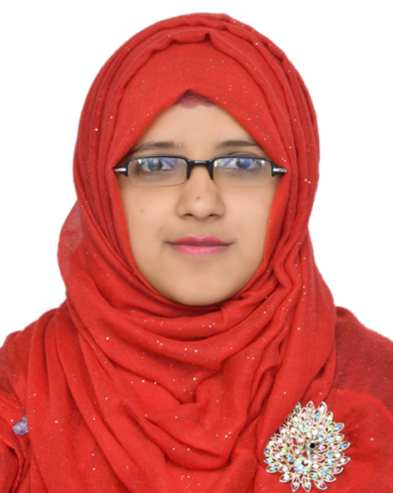
Of
Taslima Azad
Contact Address
Address: Polia, Khadim Nagor, Sylhet.
E-mail: taslimazad55@gmail.com
Mobile: +88 01742496808

Personal Particulars:

- Name : Taslima Azad
- Father’s Name : Abu Saied Md. Azad
- Mother’s Name : Habiba Khatun.
- Permanent Address : Village: Polia, P.O: Khadimnagar Dist: Sylhet
- Date of Birth : 07 August, 1993
- Nationality : Bangladeshi
- Religion : Islam
- Marital Status : Single
- Blood Group : A-
- Contact No : 01742496808
Educational Background:
B.B.A.(Honours):
B.B.A .(Hon’s) : Bachelor of Business Administration (BBA)
Major Subject : Accunting and Information Systems
Graduation Year : 2017
CGPA : 2.72(Out of 4).
Inistitution : Leading University, Sylhet, Bangladesh.
Higher Secondary Certificate (H.S.C):
Group : Business Studies.
Passing Year : 2012.
Board : Sylhet.
Institution : Jalalabad Cantonment Public School & College, Sylhet.
GPA obtained : 5.00(Out of 5).

Secondary School Certificate (S.S.C):
Group : Business Studies.
Passing Year : 2010.
Board : Sylhet.
Institution : Jalalabad Cantonment Public School & College, Sylhet.
GPA obtained : 4.88(Out of 5).

Language Proficiency:
- I have an excellent command over English and also have a good interpersonal communication skill in Bengali (Native) and English, as well as Sylhety Dialect (local language).

- Career Objectives:

To obtain a challenging position in any area of Organization that will provide future opportunities for growth and development and rendering of conceptual and organizational skills along with creativity, dynamism, enthusiasm and thus making position in corporate world. Added that to use my skills and experience that I have acquired in my education life and to dedicate my whole effort to achieve the organizational goal.
Key Skills:
- Work with various types of peoples, team based culture and deal with different ideas.
- Ability to motivate teams and employees.
- Strong desires for leading an honest life with dignity.
- Aspiration to build a career showing superior performance.
- Energetic, Sincere, hard working, honest and Dutiful.

Technical Skills & Computer Proficiency:

- Microsoft Word: MS Word, MS Excel, MS PowerPoint and familiar with the use of E-mail & Internet Browsing.
- Good typing speed.
Interest:
- Participating in Social and Creative work.
- Watching movies, travelling, and listening music

References:

1. Professor Md. Nazrul Islam
Professor and Head
Department of Business Administration
Leading University, Sylhet
Mobile: +88 01718824376
Email: nazrulaisru@yahoo.com
2. Mohammed Awal Hossen
Senior Lecturer
Department of Business Administration
Leading University, Sylhet
Cell: 01670727194
Email: ahossen178@gmail.com

Yours Sincerely,

...........................
(Taslima Azad)

