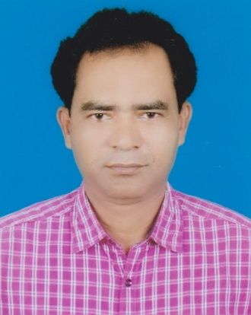

Md. Alamgir hossain.
4154 South Baipail, Road#7, Word#7
Dhamsona, Ashulia, Dhaka-1340
Mobile: 01797-130006

Career Objective:
To develop carrier in Apparel sector in the challenging environment with excellent carrier development prospects and hard work, Discipline and sincerity are the corners of success.

Strengths:
- Strong Administrative skill & competence.
- Good knowledge of personnel policies.
- Excellent communication and interpersonal skill.
- Able to work under pressure with reliable commitment to meet deadlines.
- Self-motivated and fully capable to take initiatives and make decisions.

Professional Experience

Present Occupation:

Job Period : 1st March 2018 to 15 July 2018
Job Title : GM (Quality & Compliance)
Organization : DK Global Fashion Ltd.
Organization Type : 100% Export oriented Woven, Knit & Sweater.

Responsibility:
- Technical work in knit, Sweeter & Woven.
- Communication with Customer & Merchandiser
- Quality assurance Individual.

Major Export Country: i) U.K (30%) ii) France (50%) iii) Italy (5%) vi) Israil. (15%).
Working Related Customer:

System-Jennifer, Orchestra, Philder, Xanaka, Spum, Promod, Button, next, Seven hill, Colligion, Upim, Etam, Castro etc.

Page 1 of 5

Previous Occupation:

 Job Period : 02 November 2006 to 12 February 2018.
Job Title : Sr. Quality Assurance Inspector (Grade-5B)
Organization : Li & Fung (BD) Ltd.
Organization Type : 100% Export oriented Woven, Knit & Sweater Readymade garments
Buying House.

Responsibility:
- Technical work in knit, Sweeter & Woven.
- Communication with Customer & Merchandiser
- Quality assurance Individual.

Major Export Country: i) U.K (30%) ii) France (50%) iii) Italy (5%) vi) Israil. (15%).
Working Related Customer:

System-Jennifer, Orchestra, Philder, Xanaka, Spum, Promod, Button, next, Seven hill, Upim, Etam, Castro, Riverisland Etc.

Previous Occupation:

Job Period : 1st September 2005 to 30th October 2006
Job Title : Quality manager & Fab Controller.
Organization : Manufattura Corona S.P.A Road no-2, House No- 2
Baridhara (D.O.H.S), Baridhara, Dhaka-1212

Organization Type : Italian Buying house.

Responsibility:

i) Technical work
ii) Quality control & Fab inspection.

Major Export Country:

i) France & ii) U.S.A

Page 2 of 6

Previous Occupation:

Job Period : 1st September 2002 to 30th August 2005
Job Title : Quality manager& Fab manager.
Organization : GOLD TEX GARMENTS LTD. D.E.P.Z (OLD).
Organization Type : 100% Export oriented Woven Garments Ltd.
Gonokbari, Asulia, Savar, Dhaka-1340.
Responsibility:
i) Technical work
ii) Quality control& Fab Control.

Major Export Country:
France, U.S.A& Canada.

Previous Occupation:

Job Period : 1st June 2001 to 30TH August 2002
Job Title : Quality Controller
Organization : Santa Indruisty Ltd.
D.E.P.Z (Ext- Area.)
Organization Type : 100% Export oriented Woven Garments Ltd.
Gonokbari, Asulia, Savar, Dhaka-1340.

Responsibility:

- Technical work
- Quality control

Major Export Country:

i) France & ii) U.S.A

Page 3 of 6

Job Period : 1st September 1998 to 30th May 2001
Job Title : Quality Controller
Organization : HI-Speed Buying House. (Local base buying house)
B.T.M.C Bhavan, Kauran Bazar, Dhaka-1215.

Organization Type : 100% Export oriented Woven, Knit & sweeter.

Responsibility:

i) Technical work
- Quality control

Major Export Country:

i) Canada ii) U.S.A& iii) France iv) Europe.

Job Period : 1st July 1996 to 30th August 1998
Job Title : Line chief and Quality Finishing Co-ordinator
Organization : G M Estrabishment Gmts.
Kathal Bagan Bazar, Dhaka- 1215.

Organization Type : 100% Export oriented Woven Garments.

Responsibility:
i) Supervise to make production.
ii) Co-ordinating to finishing the product.

Major Export Country: i) Canada ii) U.S.A& iii) Germany.
Working Related Customer:

Molar& Co. paksin, GDS, HEMS,CORA Etc.

Job Period : 1st August- 1994 to 30th June 1996
Job Title : Swing Supervisor

Organization : Robin Fashion Ltd.
Farmview Super market Top.
Dhaka-1215.

Organization Type : 100% Export oriented Woven Garments.
Page 4 of 6

Responsibility:

i) Supervise to production.

Major Export Country:

i) U.S.A & ii) Canada iii) Germany.

Working Related Customer:

Laradut, Barbaduta, Sedi S.A, Miles.

Job Period : 2nd May 1993 to 31st July-1994.
Job Title : Quality Inspector
Organization : Azim & Sons 42, Indra Road, Dhaka-1215.

Organization Type : 100% Export oriented Woven Garments.

Responsibility:

i) Check production in every Section in the Factory..

Language Efficiency:

Fluency in Bengali & English

Computer Skills:

* Microsoft Word & Microsoft Excel.

* I am Capable to handle E-mail & Internet.

Page 5 of 6

Personal Information:

Father’s Name : Late. Abdul Aziz.
Mother’s Name : Mrs. Rahima Begum
Present Address : 4154 South Baipail, Road#7, Word#7
Dhamsona, Ashulia, Dhaka-1340
Permanent Address : 4154 South Baipail, Road#7, Word#7
Dhamsona, Ashulia, Dhaka-1340

Date of Birth : 01-05-1974.
Marital Status : Married
Religion : Islam (Sunni)
Nationality : Bangladeshi by birth
Educational Qualification : B.A Pass.

I hereby declare the information given above are true and correct.

Yours truly,

My expected salary is -……………… / = BDT.

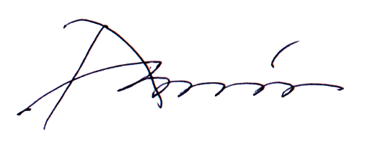

Md. Alamgir Hossain.
Date:

Page 6 of 6

