RAYHANUL ISLAM
Vill/ House : Sunargaon R/A, Chuabahar, Bateshwar, Sylhet .
Mobile no: +88 01726-658791
E-mail-rayhan.mcc1@gmail.com

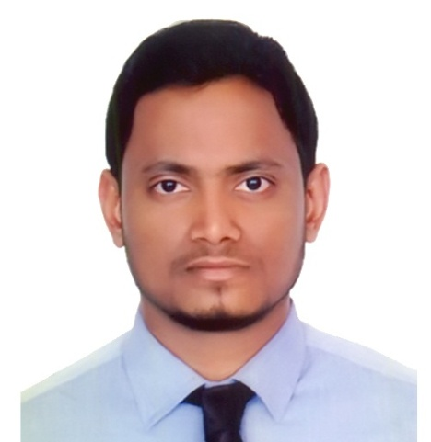

- Career objective:
Energetic dependable Student with academic experience in Economics.Currently Seeking a chance for making myself as a prepared person for the next challenging world that seeks an ambitious and career conscious person ,where acquired skills and education will be utilized towards continued growth and advancement.

- Personal Profile:

- Name : Rayhanul Islam
- Father name : Md. Jamirul Islam
- Mother name : Rehena Begum
- Date of birth : 01-01-1992
- Permanent address : Vill/ House - Sunargaon R/A, Chuabahar, Bateshwar .
- Current address : Vill/ House - Sunargaon R/A, Chuabahar, Bateshwar
- Home district: : Sylhet.
- Contact : +88 01726-658791
- Marital status: : Single
- Religion : Islam
- Nationality : Bangladeshi
- National ID No : 19929116242000035
- Gender : Male
- Hobbies : Using internet, Visit Historical place etc.

Educational Qualification

M.S.S.(Economics):

- University : National university
- Institute name : M.C. College, sylhet
- Year of passing : 2014
- Subject : Economics
- Result : Appeared

B.S.S.Hon`s (Economics):

- University : National university
- Institute name : M.C. College, sylhet
- Year of passing : 2013
- Subject : Economics
- Result : 2.73 out of 4.00

- Higher secondary certificate:

- Board : Madrasha
- Institute name : Shahjalal Jamia Islamia Kamil Madrasha
- Group : Humanities
- Year of passing: 2008
- Result : 4.42 out of 5.00

- Secondary school certificate:

- Board : Madrasha
- Institute name : S.P.P.M. Dhakil Madrasha
- Group : Humanities
- Year of passing : 2006
- Result : 4.83 out of 5.00

- Computer skill:

Operating Software | : | Windows 98/Millennium/2000/XP Professional etc.
Application Software | : | MS Office Package: Word, Excel Spreadsheet, Access, Power Point X, Adobe Photoshop Etc.

- Computer Literacy:

- Basic Computer

- Certificate no : 21404
- Course ID : BCC-SYL-ICAP -16515.
- Result :Completed Successfully.
- Institute : Bangladesh Computer Councial (BCC),Sylhet.

- Diploma (06 Months)

- Certificate no: 23076
- Course ID :BCC-SYL-DIP-02316.
- Result : 3.06 out of 4.00.
- Institute : Bangladesh Computer Councial (BCC),Sylhet.

- Language skill:

Language | Reading | Writing | Speaking
Bengali | High | High | High
English | High | High | Medium

- Reference :

 | : | Reference (1) | Reference (2)
Name | : | Md. Majibul Islam | Shafiqul Islam
Organization | : | Ex-Executive Officer, National Bank | Lecturer  Sylhet Govt. Women’s College
Address | : | Sylhet Branch, Sylhet | Tilagor,Sylhet
Cell Number | : | 01558-408011 | 01714-430466
Relation | : | Relative | Relative

- I hereby, declare that the information given above is true, fair and fully update.


Signature
(Rayhanul islam)
( - - 2017) .

