Razaulkarimrahee 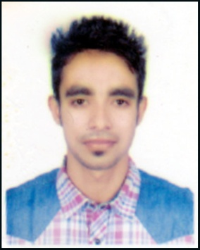
[Road no:43,House no:1,Block C,ShahajalalUposhahar,Sylhet]

[+8801621265026]•[rkrsck113@gmail.com]

Personal Profile
RazaulKarimRahee
Road no:43,House no:1,Block C,
ShahjalalUposhahar,Sylhet.
Cell: +8801621265026
Email:rkrsck113@gmail.com

Career Objective

Willing To Be APart Of Organization That Will Provide AContinous Learning And ChallengingWorking Environment.An Oppurtinity to Weigh My Communication And Interpersonal Skills Extensively Use Previously Acquired Knowledge And and ToLearn New SkillsAnd Grow.

Achievements

1) HeldA Perfect Attendance Record

2)Introduced Company Offers in Different people.
3) Fulfil Company Demand.
4) Established A Good Working Relationships With Customers.
5) Became A Brand Ambassador Of Robi.

Education and Training

[2013-2017] B.S.C(HONOURS) LEADING UNIVERSITY, SYLHET .

(Completed on Computer Science & Engineering)

[2010 – 2012] H.S.C(HIGHER SECONDARYSCHOOL CERTIFICATE) [M.C COLLEGE,SYLHET]

5.00 out of 5.00

[2008-2010] S.S.C(SECONDARY SCHOOL CERTIFICATE)

[SHAJALAL JAMIA ISLAMIA SCHOOL AND COLLEGE,SYLHET]
5.00 OUT OF 5.00
Employment

[2016– 2017] BP(BRAND PROMOTING) [ROBI AXIATA LIMITED]

1)Brand promoting.
2)Understanding cumtomer demand and knowledge.
3)providing internet facilities.
4)Brand Ambassador.

Skills

Technical:
1) Adobe Photoshop(Expert in Graphics Designing),Adobe Illustrator.
2) Google Analytics, Social Networks .
3) Operating System In Windows, IOS, Android.
4) HTML & CSS.
5.MS Office, Excell, Android.
6. Basic Wordpress.

Interpersonal:

1) Communication.
2) Effective Listening.
3)Decision Making Skills.
4)Team Player.
5)Appreciative
6)Coping With Pressure.
7)Leader Qualities.

Other:

1) Also Work As A Examiner inSohidChanduScholarShip Examination And SohidSuleman Scholarship Examination.

2)Working As A Active Member In Leading University Rotary Club, Leading University Social Service Club And In Rotary Club Of Sylhet.

Hobbies and interests

1) Photography

2) Playing Any kinds Of Game.
3) Travelling Different Places For Entertainment And Gathering Knowledge.
4) Want To Help People And Do Something For The Orphan Childrens.

References

Mahfuz Ahmed Chowdhury
Customer Service Officer
RobiAxiataLimited,Sylhet Branch.
+8801819550504

Hassan Abdul Mannan
Branch Operations Manager
Standard Chartered Bank, Sylhet
+8801819820842

