CURRICULUM VITAE
SHAFIQUL ISLAM  Hous no: 365, Road no: 02, Master Colline.  Kishoreganj Sador , Dist.: Kishoregonj.  Mobile : Mobile : +088 01740422001  Email: shafiqulislamwajib@gmail.com | 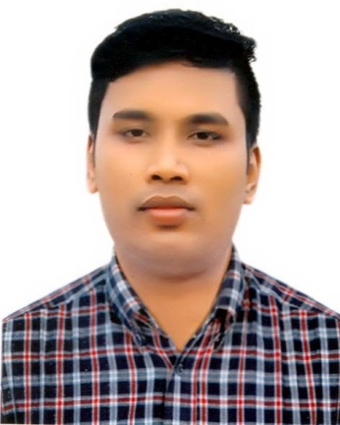
Date of Birth : 16th August,1989
Gender : Male
Nationality : Bangladesh
Language : English, Bangla

Work Experience | :One year internship in various hospitals of Gono Shasthaya Kendra
Skills | : Physiotherapy
Industry | : Hospitals/ Health Care /Education
Function | : Health Care
Roles | : Physiotherapist
Authorized to work in | : Authorized to work in Bangladesh
Highest Degree Held | : Bachelor of Physiotherapy (B.P.T)
Preferred Job Location | : Anywhere
Desired Job Type | : Permanent Full Time

Detailed Resume
PERSONAL DETAILS

Name : Shafiqul Islam
Father’s Name : MD. Badal Miah
Mother’s Name : Kalpana Akter
Permanent Address : Hous no: 365, Road no: 02, Master Colline.
Kishoreganj Sador , Dist.: Kishoregonj.
Gender : Male
Religion : Muslim
Marital Status : Single
Date of birth : 16/08/1989
Nationality : Bangladeshi

EDUCATIONAL QUALIFICATIONS

City University –

MPH - Master of Public Health (On Course)

Department of Physiotherapy - Bachelor of Physiotherapy (B.P.T)
– Passed.
(GONO BISHWABIDYALAY) (Session : 2009-2014)
Post: Mirzanagar, Savar, Dhaka, Bangladesh.

WALI NEWAZ KHAN COLLEGE KISHOREGANJ
-Higher Secondary Certificate (H.S.C) – CGPA 3.70/5.00
(Dhaka Board) (10.09.2008)
Dhaka, Bangladesh.

BAZITPUR HAFEZ A. RAZZAK PILOT HIGH SCHOOL, BAZITPUR, KISHOREGANJ
-Secondary School Certificate (S.S.C) – CGPA 4.06/5.00
(Dhaka Board) (22.06.2006)
Dhaka, Bangladesh.

CONTINUING MY PROFESSIONAL DEVELOPMENT:

Participated “4th National Physiotherapy Congress” Conducted by Bangladesh Physiotherapy Association at Senate Bhaban, Dhaka University on 14th October 2011.

Research Experience:

“IMPACT OF ADHESIVE CAPSULITIS AND THERAPEUTIC EFFECTS OF HIGH GRADE AND LOW GRADE MOBILIZATION TECHNIQUE” submitted to Department of Physiotherapy, Gono Bishwabidyalay.

Community Service:

▪ Participated and Conducted Free Health Camps and Physiotherapy Camps inside and outside the campus which was conducted by Gonoshasthay kendro
▪ Have been an enthusiastic person in donating blood.

Creativity in Profession:
▪ Having precise knowledge in current trends of Physiotherapy practice, I am treating through ‘Evidence Based Physiotherapy and Manual therapy’ for my patients.
.Certificate in special child care .
Working Experience:

Coordinator & Chartered Physiotherapist
▪ Institute of Neurodevelopment & Research(INDR),52/1,New Eskaton,Dhaka-1000.
Clinical Physiotherapist
▪ Brighton Hospital and Diagnostic Center, Hatirpool, Dhaka, (01-03-2014 to 01-07-2014)
Physiotherapist
▪ National Institute of Re-habitation for Paralyse Hospital – DBKP
Chonpara, Rupgonj, Narayangonj, (01-09-2014 to 31-10-2016)

PROFESSIONAL REFEREE'S

Dr.Mohan Nallathambi.  MPT- Adv.PT in Neurology, MIAP  Associate Professor & Head  Department of Physiotherapy,  Gono Bishwabidyalay,  Senior Consultant Physical Therapist, Gonoshasthaya Kendra  Savar, Dhaka, Bangladesh -1344.  Contact Phone: 0088 01741027760. | Dr.Osman Gony.  Neuro- Rehabilitation Specialist  Chartered Physiotherapist  osman@OxfordBookes.net  Founders & chairman of INDR (Institute of NeuroDvelopment & Research)  52/1,New Eskaton Road, Dhaka-1000  Contact Phone: 01931405986

Declaration
I hereby declare that all the above statements are true to the best of my knowledge and belief.

Shafiqul islam

Date :04-12-2019 Signature of the Candidate

