Resume OF

Zakia Sultana
Contact: -8801680929509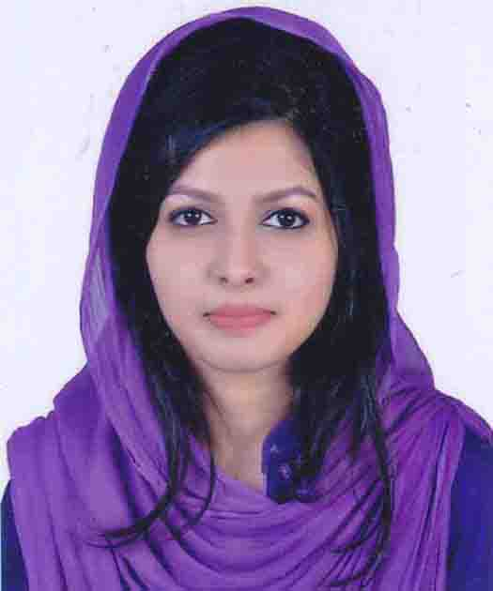
42/4 Bonkolapara, Shubidbazar, Sylhet,
Bangladesh
Email: zakiasultanaa@gmail.com

Objectives

To achieve a position related to my field of specialization which allows me to apply my knowledge and skills for betterment of the organization.

Educational Profile:
- Bachelor of Science in Computer Science and Engineering
Institute: Metropolitan University
Discipline: Science
Year of passing: 2018
Result: 3.61/4.00
- Higher Secondary Certificate (HSC):
Institute:SylhetGovt. Women’s College
Group: Science
Board: Sylhet
Year of passing: 2014
Result:4.70/5.00
- Secondary School Certificate(SSC)
Institute: Blue Bird School and college, Sylhet
Group: Science
Board: Sylhet
Year of passing: 2012
Result:5.00/5.00

Technical Skill:

Language: C, HTML, JS, JAVA, CSS

Other Expertise: MS Word, MS Excel, MS Power Point etc.

Language skill:

- Strong written and verbal communication ability in Bengali.
- Strong written and verbal communication ability in English.

Personal Profile

Name : Zakia Sultana
Father’s Name : MD. Mokhlisur Rahman
Mother’s Name : Subena Begum
Sex : Female
Date of Birth : 24 June1995
Religion : Islam
Nationality : Bangladeshi
Marital status : Single
Blood group : B⁺
Contact number : 8801680929509

Reference
Name: | Mahruba Sharmin Chowdhury
Designation: | Ast. Professor, CSE
Organization: | SUST
Mobile: | +8801917566699
Relation: | Family

Declaration

I, the undersigned do hereby state that to the base of my knowledge and belief, the
Above mentioned data correctly described my qualification, experience and me.

